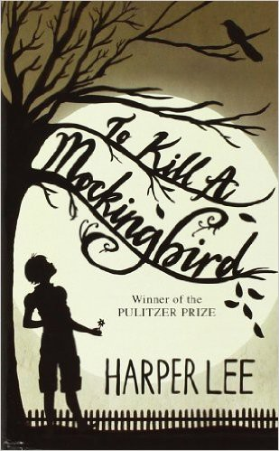

Name: Date: Period:

**Close Reading Organizer - Chapter 19**

**Directions:** Read each summary entry and think about which themes listed in the Themes Key apply to it, then color

in those themes in the Theme Tracker. Next, write a few sentences of Analysis to explain how the themes you chose apply to each summary section.

**Themes Key**

Good, Evil, and Human Dignity

Prejudice Growing Up Courage

Small Town Southern Life

**Summary**

**Theme Tracker**

**Your Analysis**

**Atticus** calls **Tom Robinson** to the stand. Tom says he often helped **Mayella** with chores. On this occasion, he says, Mayella threw herself at him. He tried to leave, but was scared to push her out of the way.

Suddenly, **Bob Ewell** showed up and yelled at Mayella, "You goddamn whore, I'll kill ya." Tom ran.

1

2

3

4

5

**Link Deas**, stands up in the crowd and says that **Tom** is a good man. **Judge Taylor** expels Deas from the courthouse.

1

2

3

4

5

**Mr. Gilmer** cross-examines. He calls **Tom** "boy" in a nasty tone, and tricks Tom into saying he felt sorry for **Mayella**, which causes a murmur of anger and disgust in the courtroom. Mr. Gilmer asks why Tom ran if he was innocent. Tom says that a black man has to run in any bad situation.

1

2

3

4

5

**Dill** starts to cry and **Scout** takes him outside. Dill says he can't stand the way Gilmer was talking to **Tom**.

1

2

3

4

5

5

4

3

2

1