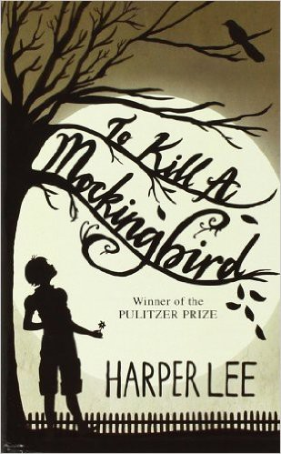

Name: Date: Period:

**Close Reading Organizer - Chapter 20**

**Directions:** Read each summary entry and think about which themes listed in the Themes Key apply to it, then color

in those themes in the Theme Tracker. Next, write a few sentences of Analysis to explain how the themes you chose apply to each summary section.

**Themes Key**

Good, Evil, and Human Dignity

Prejudice Growing Up Courage

Small Town Southern Life

**Summary**

**Theme Tracker**

**Your Analysis**

Outside the courthouse, **Mr. Dolphus Raymond** sympathizes with **Dill** about the way white people treat black people without even stopping to think that blacks are people too. Raymond is an eccentric rich white man. He gets little respect from the white people in the town because he's always drunk and lives with a black woman and has fathered interracial children. But Dill and **Scout** learn that Raymond isn't actually a drunk: he only drinks Coca-cola. Mr. Raymond explains that he fakes being a drunk so people won't bother him for living the way he wants.

1

2

3

4

5

**Atticus** is making his closing remarks when

**Dill** and **Scout** get back to their seats. Atticus notes the prosecution's lack of evidence, then says the courtroom is the one place in America where every man is equal, and asks the jury to "do its duty."

1

2

3

4

5

5

4

3

2

1