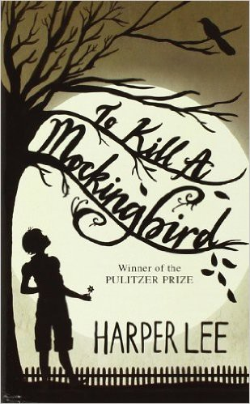

Name: Date: Period:

**Close Reading Organizer - Chapter 21**

**Directions:** Read each summary entry and think about which themes listed in the Themes Key apply to it, then color

in those themes in the Theme Tracker. Next, write a few sentences of Analysis to explain how the themes you chose apply to each summary section.

**Themes Key**

Good, Evil, and Human Dignity

Prejudice Growing Up Courage

Small Town Southern Life

**Summary**

**Theme Tracker**

**Your Analysis**

**Calpurnia** enters the courtroom. She tells **Atticus** that **Jem**, **Scout**, and **Dill** are missing. **Mr. Underwood** says they're sitting in the balcony. Atticus tells them to go home and eat lunch, but relents and says they can come back for the verdict if it hasn't already been delivered.

1

2

3

4

5

An hour later, **Scout**, **Jem**, and **Dill** get back to the silent, tense courtroom. The jury is still deliberating. Jem is confident of victory because all the evidence is in **Tom**'s favor.

1

2

3

4

5

**Heck Tate** calls the court to order. The jury comes back and does not look at **Tom**.

**Scout** knows this means the verdict is guilty. It is.

1

2

3

4

5

5

4

3

2

1