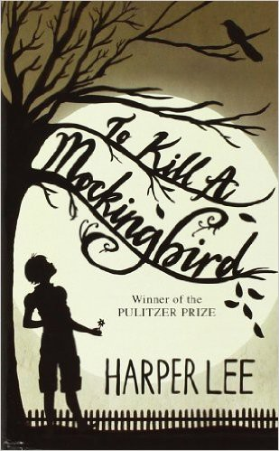

Name: Date: Period:

**Close Reading Organizer - Chapter 22**

**Directions:** Read each summary entry and think about which themes listed in the Themes Key apply to it, then color

in those themes in the Theme Tracker. Next, write a few sentences of Analysis to explain how the themes you chose apply to each summary section.

**Themes Key**

Good, Evil, and Human Dignity

Prejudice Growing Up Courage

Small Town Southern Life

**Summary**

**Theme Tracker**

**Your Analysis**

**Jem** cries. He can't understand how the jury could convict **Tom**. **Atticus** says they've done it before and they'll do it again and only the children will weep.

1

2

3

4

5

The next morning, the Finches wake to discover that the black community of Maycomb has brought them baskets of food in thanks for **Atticus**'s defense of **Tom**.

1

2

3

4

5

That afternoon, **Jem** tells **Miss Maudie** he used to think the people of Maycomb were the best people in the world, but no longer does. Miss Maudie says the trial was a step in the right direction, and that there are good people in Maycomb. For instance, it's no coincidence **Judge Taylor** appointed **Atticus** to take **Tom**'s case.

1

2

3

4

5

Suddenly **Miss Stephanie Crawford** runs up with gossip: **Bob Ewell** just threatened **Atticus** and spit in his face.

1

2

3

4

5

5

4

3

2

1