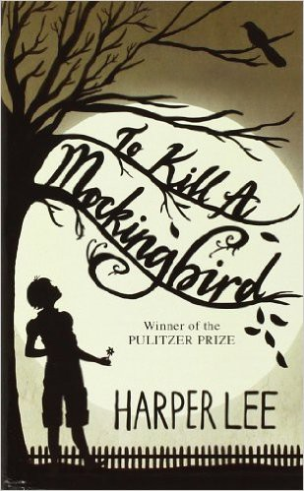

Name: Date: Period:

**Close Reading Organizer - Chapter 23**

**Directions:** Read each summary entry and think about which themes listed in the Themes Key apply to it, then color

in those themes in the Theme Tracker. Next, write a few sentences of Analysis to explain how the themes you chose apply to each summary section.

**Themes Key**

Good, Evil, and Human Dignity

Prejudice Growing Up Courage

Small Town Southern Life

**Summary**

**Theme Tracker**

**Your Analysis**

**Jem** and **Scout** are terrified Ewell will attack **Atticus**. Atticus, thinks Ewell has already gotten the need for revenge out of his system, though Aunt **Alexandra** isn't so sure.

1

2

3

4

5

Meanwhile, **Tom Robinson** is in prison. **Atticus** thinks he has a good shot of winning on appeal. If he loses, though, Tom will be executed. When **Jem** expresses disdain for the jury that convicted Tom, Atticus says that one man on the jury, a Cunningham, almost voted for acquittal. This news inspires **Scout** to declare she's going to invite **Walter Cunningham** to dinner, but Aunt **Alexandra** forbids it. She says the Finches are too good for the Cunninghams.

1

2

3

4

5

Later that night, **Scout** and **Jem** try to figure out why people are prejudiced. They come up with all sorts of reasons but none seems sufficient. Jem realizes **Boo Radley** stays in his house because he wants to.

1

2

3

4

5

5

4

3

2

1