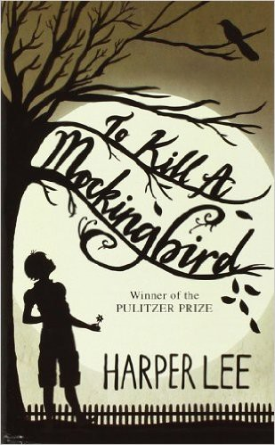

Name: Date: Period:

**Jean Louise Finch (Scout) Answer Key**

***Evidence and Analysis***

**Directions:** Gather quotes and other examples from the text to use as

evidence that provides insight into Jean Louise Finch (Scout). Then write a paragraph that describes and analyzes Jean Louise Finch (Scout), including relationships, traits, motivations, fears, and how (or if) they develop over the course of the text.

**Character Description and Analysis**

The narrator of *To Kill a Mockingbird*, Scout is **Atticus**'s daughter, **Jem**'s sister, **Alexandra** and **Jack**'s niece, and friends with **Dill**. In the three years the novel covers, she grows from six-years-old to nine. Scout is intelligent and loves to read, but is also headstrong, outspoken, and a tomboy. As the novel opens, Scout is both innocent and intolerant of anything new or different. Scout's innocence falls away in part because she is growing up and in part from the trial of Tom Robinson: she discovers how cruel and violent people can be. But she also learns, through Atticus's careful teaching, that the necessary response to intolerance is to try to understand its origins, to relate to people in terms of their dignity rather than their anger, and to use that foundation as a way to try to slowly change their minds.

**Evidence**

1.

2.

3.

4.

5.

6.



Name: Date: Period:

**Jeremy Atticus Finch (Jem) Answer Key**

***Evidence and Analysis***

**Directions:** Gather quotes and other examples from the text to use as

evidence that provides insight into Jeremy Atticus Finch (Jem). Then write a paragraph that describes and analyzes Jeremy Atticus Finch (Jem), including relationships, traits, motivations, fears, and how (or if) they develop over the course of the text.

**Character Description and Analysis**

**Scout**'s older brother and **Atticus**'s son. Jem is four years older than Scout, and therefore understands many of the events in Maycomb in a way that the younger Scout can't. Intelligent and adventurous as a child, Jem never loses these qualities but also grows into a young man who is strong, serious, idealistic, and sensitive. While both Scout and Jem love Atticus, Jem also reveres the justice and moral character that Atticus stands for, and which he wants to one day stand for himself.

**Evidence**

1.

2.

3.

4.

5.

6.



Name: Date: Period:

**Atticus Finch Answer Key**

***Evidence and Analysis***

**Directions:** Gather quotes and other examples from the text to use as

evidence that provides insight into Atticus Finch. Then write a paragraph that describes and analyzes Atticus Finch, including relationships, traits, motivations, fears, and how (or if) they develop over the course of the text.

**Character Description and Analysis**

**Scout** and **Jem**'s widowed father, and **Alexandra** and **Jack**'s brother. He employs **Calpurnia**, but thinks of her as family. A distinguished lawyer in Maycomb, Atticus believes in moral integrity, and stands up against the racism of Maycomb to defend a black man, **Tom Robinson**, falsely accused of rape by a white man, **Bob Ewell**. Yet as much as Atticus believes in acting morally, he does not believe in righteously condemning those who don't always act morally. Instead, Atticus teaches his children to search out and respect the dignity of every human being, to try to see the world from their individual point of view. Atticus Finch has become one of the great father figures in American literature.

**Evidence**

1.

2.

3.

4.

5.

6.



Name: Date: Period:

**Arthur Radley (Boo) Answer Key**

***Evidence and Analysis***

**Directions:** Gather quotes and other examples from the text to use as

evidence that provides insight into Arthur Radley (Boo). Then write a paragraph that describes and analyzes Arthur Radley (Boo), including relationships, traits, motivations, fears, and how (or if) they develop over the course of the text.

**Character Description and Analysis**

A recluse who never sets foot outside his house, Arthur is an object of fascination for many Maycomb residents. Many rumors describe Arthur as a kind of monster who stabbed his father as a boy, eats cats, and haunts the neighborhood at night. He turns out to be innocent, gentle, kind, protective of children, intensely shy, and one of the mockingbirds to which the title of *To Kill a Mockingbird* refers.

**Evidence**

1.

2.

3.

4.

5.

6.



Name: Date: Period:

**Charles Baker Harris (Dill) Answer Key**

***Evidence and Analysis***

**Directions:** Gather quotes and other examples from the text to use as

evidence that provides insight into Charles Baker Harris (Dill). Then write a paragraph that describes and analyzes Charles Baker Harris (Dill), including relationships, traits, motivations, fears, and how (or if) they develop over the course of the text.

**Character Description and Analysis**

**Jem** and **Scout**'s friend, who visits Maycomb each summer from his home in Meridian, Alabama. Miss Rachel Haverford is his aunt. Dill is an intensely imaginative and sensitive boy who uses his imagination to hide loneliness and pain: though his mother is divorced, he constantly makes up stories about the greatness of the father he barely knows. Dill is obsessed with Boo Radley.

**Evidence**

1.

2.

3.

4.

5.

6.