Meme Assignment (Criterion C)
Due: March March 9, 2017

We all know how much Ms. Benko loves memes! Now it's your turn to create a meme on something we have learned in class! This assignment should be fun and creative!

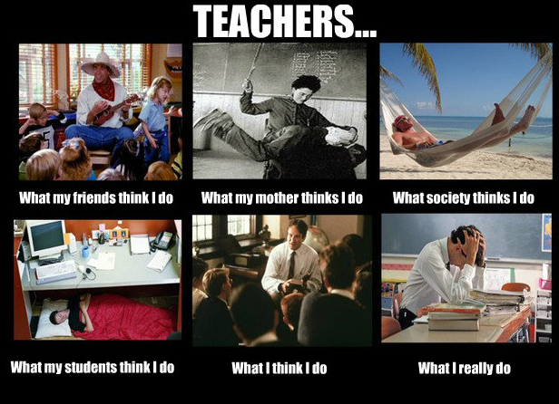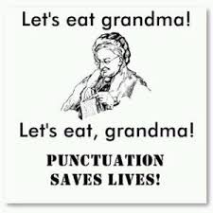

Options:

- Take a character from To Kill a Mockingbird and create a meme that shows how other characters perceive him. For example: If you choose to make a meme about Atticus. Put Atticus’s name on the top then: What my neighbors think I do? What Tom thinks I do? What the people of Maycomb think I do? What my children think I do? What I think I do? What I really do?

- Take a common grammar mistake (your vs you’re, their, there, they’re, etc.) and develop a meme.

To create your meme, go to https://imgflip.com/memegenerator or https://imgflip.com/memegenerator/13497067/What-I-really-do and add your images and captions. I want to put these up on the “humour” section of the class website so please ensure all humour and images are school appropriate. Upon completing your meme, send it to me in an e-mail: jbenko@sd44.ca. Please use as an image file Note: I'm not sure if you can save this as a work in progress, so you may want to make sure you have selected all of your images before you begin creating your meme.

*If you finish early (or just love making memes) you can do more memes for fun!
Possible idea: You could make a meme about being in high school. You could do something similar to the first option. Example: What I do? What my parents think I do? What society thinks I do?,*

