Paragraph Graphic Organizer

Question:

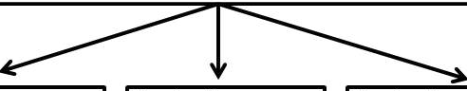
Topic Sentence:
Supporting Reason 1
Supporting Reason 2
Supporting Reason 3

Concluding sentence:

....

